
SCHOOL OF BUSINESS
GENDER EQUALITY PLAN
2027–2030

Document status: Draft for stakeholder consultation and institutional approval. This Faculty Gender Equality Plan is designed to complement and operate in alignment with Atılım University’s existing policies, institutional frameworks, and any University-level Gender Equality Plan or equivalent strategy.
Ankara • September 2026

Introduction
This Gender Equality Plan (GEP) provides the School of Business with a practical and structured framework for advancing gender equality during the 2027–2030 period. It brings together the faculty’s available baseline data, identified priority areas, planned actions, institutional responsibilities, monitoring arrangements and relevant Horizon Europe requirements within a single implementation framework. The Plan is intended not only to support compliance with external expectations, but also to strengthen the integration of gender equality into the academic, administrative and decision-making processes.
The GEP is designed to be implemented through existing School of Business and University structures, with responsibilities shared across the Dean’s Office, relevant departments, administrative units and other institutional bodies. Its implementation will be supported by regular monitoring, systematic review of available gender-disaggregated data, and documentation of progress against agreed actions and indicators. Where baseline information is not yet available, the plan establishes a basis for strengthening data collection and monitoring during the implementation period.
The plan also provides a framework for reviewing progress over time and for adapting actions where necessary. Regular internal review is intended to ensure that the GEP remains responsive to verified data, institutional experience, stakeholder feedback and emerging needs. In this way, the plan serves both as an operational tool for the 2027–2030 period and as a basis for continuous institutional improvement in areas such as representation, leadership, work-life balance, recruitment and career development, teaching and research, and the prevention of gender-based discrimination and harassment.

Content
Executive Summary | 3
1. Purpose, Scope and Institutional Position | 4
2. Policy and Institutional Framework | 5
3. Governance, Responsibilities and Resources | 6
4. Baseline Gender Equality Assessment | 7–10
5. Strategic Priorities and Objectives | 11
6. Action Plan 2027–2030 | 12–14
7. Monitoring, Evaluation and Annual Indicators | 14-15
8. Approval and Entry into Force | 15
References | 15

Executive Summary
Atılım University School of Business is committed to promoting gender equality across education, research, employment, leadership and institutional life. The Gender Equality Plan 2027–2030 sets out the faculty’s priorities and actions for strengthening equal opportunity, supporting an inclusive working and learning environment, and integrating gender equality into relevant academic and administrative processes. The plan builds on Atılım University’s existing institutional policies, mechanisms and support structures and provides a clear framework for implementation, monitoring and regular review. It is intended to support a consistent and evidence-based approach to gender equality while allowing the faculty to respond to differences that may emerge across departments, programs and decision-making structures over time.

The 2026 baseline covers ten departments/programs, 1,365 students and 64 academic staff members. Among students, 520 are female (38.1%) and 845 are male (61.9%). Among academic staff, 30 are female (46.9%) and 34 are male (53.1%). The school will use these figures as the starting point for monitoring representation throughout the implementation period. Department-level data are also presented because the pattern of representation differs across programs, and aggregate figures alone do not fully capture these variations. Monitoring at both faculty and department level will therefore help identify where representation is relatively balanced and where additional attention may be needed.

Leadership and governance are monitored separately to provide a more complete picture of participation in decision-making. Among the eight Heads of Department included in the baseline, one is female (12.5%) and seven are male (87.5%). The Faculty Board consists of six women (40.0%) and nine men (60.0%), while the Faculty Administrative Board consists of five women (71.4%) and two men (28.6%). These figures show that gender representation varies considerably across leadership and governance structures. For this reason, the Plan places particular emphasis on continued monitoring of leadership, committee participation and decision-making roles, rather than relying solely on overall academic staff composition.

The Faculty GEP addresses five priority areas: work–life balance and organizational culture; leadership and decision-making; recruitment and career progression; the gender dimension in teaching and research; and measures against gender-based violence and sexual harassment. Each priority area is supported by specific actions, indicators, responsibilities and an implementation timetable. Together, these priorities are intended to strengthen institutional awareness, improve the visibility of gender-related patterns, support fair and inclusive practices, and encourage the systematic consideration of gender equality within the school’s academic and administrative activities.

The Plan is also supported by existing Atılım University mechanisms. The University’s Senate-approved policy on gender-based discrimination, sexual harassment and sexual assault establishes institutional principles on equality, inclusion, awareness, prevention, support and protection. KASAUM provides an established University structure for research, training, awareness-raising and cooperation in this field. The school will therefore implement the GEP in coordination with relevant University units, including KASAUM, Human Resources and other responsible administrative and academic bodies. This approach is intended to avoid duplication, make use of existing institutional expertise and ensure that Faculty-level actions remain consistent with university-wide policies and practices.
1. Purpose, Scope and Institutional Position
1.1 Purpose
The faculty aims to promote gender equality as an integral part of its education, research, employment, governance and working environment. The GEP provides a framework for identifying representation patterns, supporting equal opportunity, improving awareness and monitoring progress through measurable actions. The faculty will use the Plan to guide implementation during 2027–2030 and to support continuous institutional improvement.
1.2 Scope
The plan applies to the School of Business and to its departments, programs and relevant academic and administrative activities. It covers academic and administrative staff, full-time and part-time personnel, undergraduate and postgraduate students, and, where relevant, visiting researchers, project partners, alumni and external stakeholders participating in faculty activities. The scope of the GEP extends across the main areas of faculty life in which gender equality considerations may arise. These include recruitment and career development, participation in leadership and decision-making, working and learning conditions, access to academic and professional development opportunities, teaching and curriculum-related activities, research and project development, institutional events and representation, and awareness of mechanisms relating to discrimination, harassment and gender-based violence.
Where responsibilities or procedures fall under university-level units rather than the faculty itself, the faculty will work in coordination with the relevant institutional structures. This is particularly important in areas such as human resources, research support, training, institutional quality assurance and mechanisms for the prevention of and response to gender-based discrimination and sexual harassment. The plan therefore defines the faculty’s contribution within the broader institutional framework of Atılım University rather than establishing parallel procedures where university-level mechanisms already exist.
Implementation will take account of the different characteristics of departments and programs. Faculty-level indicators will be complemented, where appropriate and consistent with privacy requirements, by department or program-level information so that differences in representation and participation are not obscured by aggregate figures.
1.3 Institutional position of the Faculty GEP
The Faculty GEP is a faculty-level implementation, monitoring and improvement framework. It translates the faculty’s commitment to gender equality into a set of priorities, actions, responsibilities and monitoring arrangements that are relevant to its own academic and administrative context.
The plan is designed to operate within the existing institutional framework of Atılım University. It builds on university policies and structures relating to equality, non-discrimination, academic and administrative employment, quality assurance, research, student experience and the prevention of gender-based discrimination, sexual harassment and sexual assault. Where appropriate, implementation will be coordinated with relevant University units so that faculty-level actions remain consistent with established institutional policies and procedures.
1.4 Design principles
The plan is based on four principles: the use of verified data, proportionate action, coordination with existing institutional structures, and regular monitoring. Actions are linked either to observed baseline patterns or to clearly identified areas where additional data is required. The plan does not treat numerical balance as an automatic measure of equality and does not introduce quotas unless separately required by law or institutional policy.

2. Policy and Institutional Framework
2.1 Horizon Europe framework
Horizon Europe requires eligible higher education institutions to maintain a public Gender Equality Plan supported by dedicated resources, gender-disaggregated data and monitoring, and training and awareness-raising. European guidance also recommends action on work–life balance and organizational culture, leadership and decision-making, recruitment and career progression, the gender dimension in research and teaching, and measures against gender-based violence.
This faculty GEP addresses these requirements through its governance arrangements, baseline and monitoring framework, training actions, five priority areas, public reporting provisions and approval process.
2.2 Atılım University policy foundation
The Faculty GEP builds on Atılım University’s Policy Document on the Prevention of Gender-Based Discrimination, Sexual Harassment and Sexual Assault, adopted by Senate Decision No. 12 dated 24 July 2020. The policy confirms the University’s commitment to ensuring that all members of the University community can participate in academic life, education, research and institutional services on an equal basis. It also establishes principles and strategies for preventing gender-based discrimination, sexual harassment and sexual assault and for strengthening a safe and inclusive academic environment.
The University policy provides an important institutional foundation for the Faculty GEP because it addresses gender equality not only as a matter of protection from discrimination, but also as an issue to be considered across academic and administrative processes. It promotes awareness-raising among academic and administrative staff, equal opportunity in employment, greater participation of women in decision-making, work–life balance, gender-sensitive strategic planning and budgeting, support for gender-related research, the preparation of equality action plans and the provision of regular training.
The policy also establishes an institutional approach to prevention, protection and support in relation to gender-based violence and harassment. It addresses confidentiality, the prevention of secondary victimization, appropriate support mechanisms, awareness of violence, digital harassment and retaliation. These provisions are directly relevant to the implementation of the Faculty GEP and provide an established University framework within which Faculty-level actions can be developed.
Accordingly, the Faculty GEP does not seek to create parallel procedures in areas already governed by university-level policies and mechanisms. Instead, it aims to strengthen the visibility, accessibility and implementation of existing commitments within the faculty context. Where actions require coordination beyond the faculty, the relevant University units will be involved so that implementation remains consistent with established institutional policies and responsibilities.
2.3 KASAUM as an institutional resource
The Atılım University Women’s Studies Research and Application Centre (KASAUM) is an established institutional resource that can support the implementation of this plan. Its formal mandate includes conducting and supporting research and projects, organizing national and international conferences, congresses, courses and seminars, contributing to teaching at undergraduate and postgraduate levels, providing consultancy, encouraging publication, developing relevant information resources and cooperating with public, private and international organizations. KASAUM’s experience and institutional role provide an important source of expertise for the faculty in areas such as training, awareness-raising, consultation and the development of gender-sensitive practices. The faculty will therefore cooperate with KASAUM, within its mandate, in the implementation of relevant GEP actions and in activities that can benefit from specialized knowledge or existing University-level experience.
3. Governance, Responsibilities and Resources
The Dean’s Office has overall responsibility for the Faculty GEP. A Faculty Gender Equality Committee is proposed to coordinate implementation, data collection, training, reporting and follow-up. Departmental contact persons will support data validation and local implementation. The faculty will work with KASAUM, Human Resources, the Faculty Secretariat and relevant quality and accreditation structures according to their existing responsibilities.

Structure | Primary responsibility | Minimum evidence/output
Dean’s Office | Owns the plan; confirms priorities; facilitates resources and institutional coordination; reviews annual results. | Annual management review
Faculty GEP Committee | Coordinates data, actions, training, reporting and follow-up; consolidates departmental evidence. | Six-monthly implementation record
Department GEP contact persons | Support department-level data validation, action delivery and communication. | Department indicator update
Faculty Secretariat | Provides administrative records, meeting support and document control. | Verified administrative evidence
KASAUM / relevant University units | Provide institutional alignment, subject expertise, training or referral support within their existing mandates. | Training/coordination evidence
Quality / accreditation structures | Connect GEP findings to continuous-improvement processes and evidence files. | Continuous improvement record based on the Plan–Do–Check–Act (PDCA) cycle
Students and other stakeholders | Provide structured feedback through consultation and survey mechanisms. | Consultation/survey record

3.1 Dedicated resources
The faculty is committed to providing the resources needed for implementation. These resources may include assigned staff time, administrative support, data analysis, training activities, communication materials and, where necessary, expert support. The exact level of annual financial support will be determined through the University’s normal planning and budgeting processes.

3.2 Data governance and privacy
Gender-disaggregated data will be collected and reported in a way that protects privacy and complies with applicable data-protection requirements. Public reporting will use aggregated data. Where numbers are small, the faculty will avoid publishing combinations of information that could identify individuals. Any data beyond the female/male categories used in the current baseline will only be collected where there is a clear legal basis, a defined purpose and appropriate safeguards.

4. Baseline Gender Equality Assessment
4.1 Data basis and method
The 2026 baseline draws exclusively on verified data collected for the preparation of this plan. It covers ten programs and includes gender-disaggregated data on students, academic staff, administrative staff, Heads of Department, the Faculty Board and the Faculty Administrative Board. The baseline is used to describe the current distribution of women and men across the main groups represented within the Faculty and to provide a reference point for future monitoring. The figures do not, by themselves, explain the reasons for differences in representation and are not used as quotas.

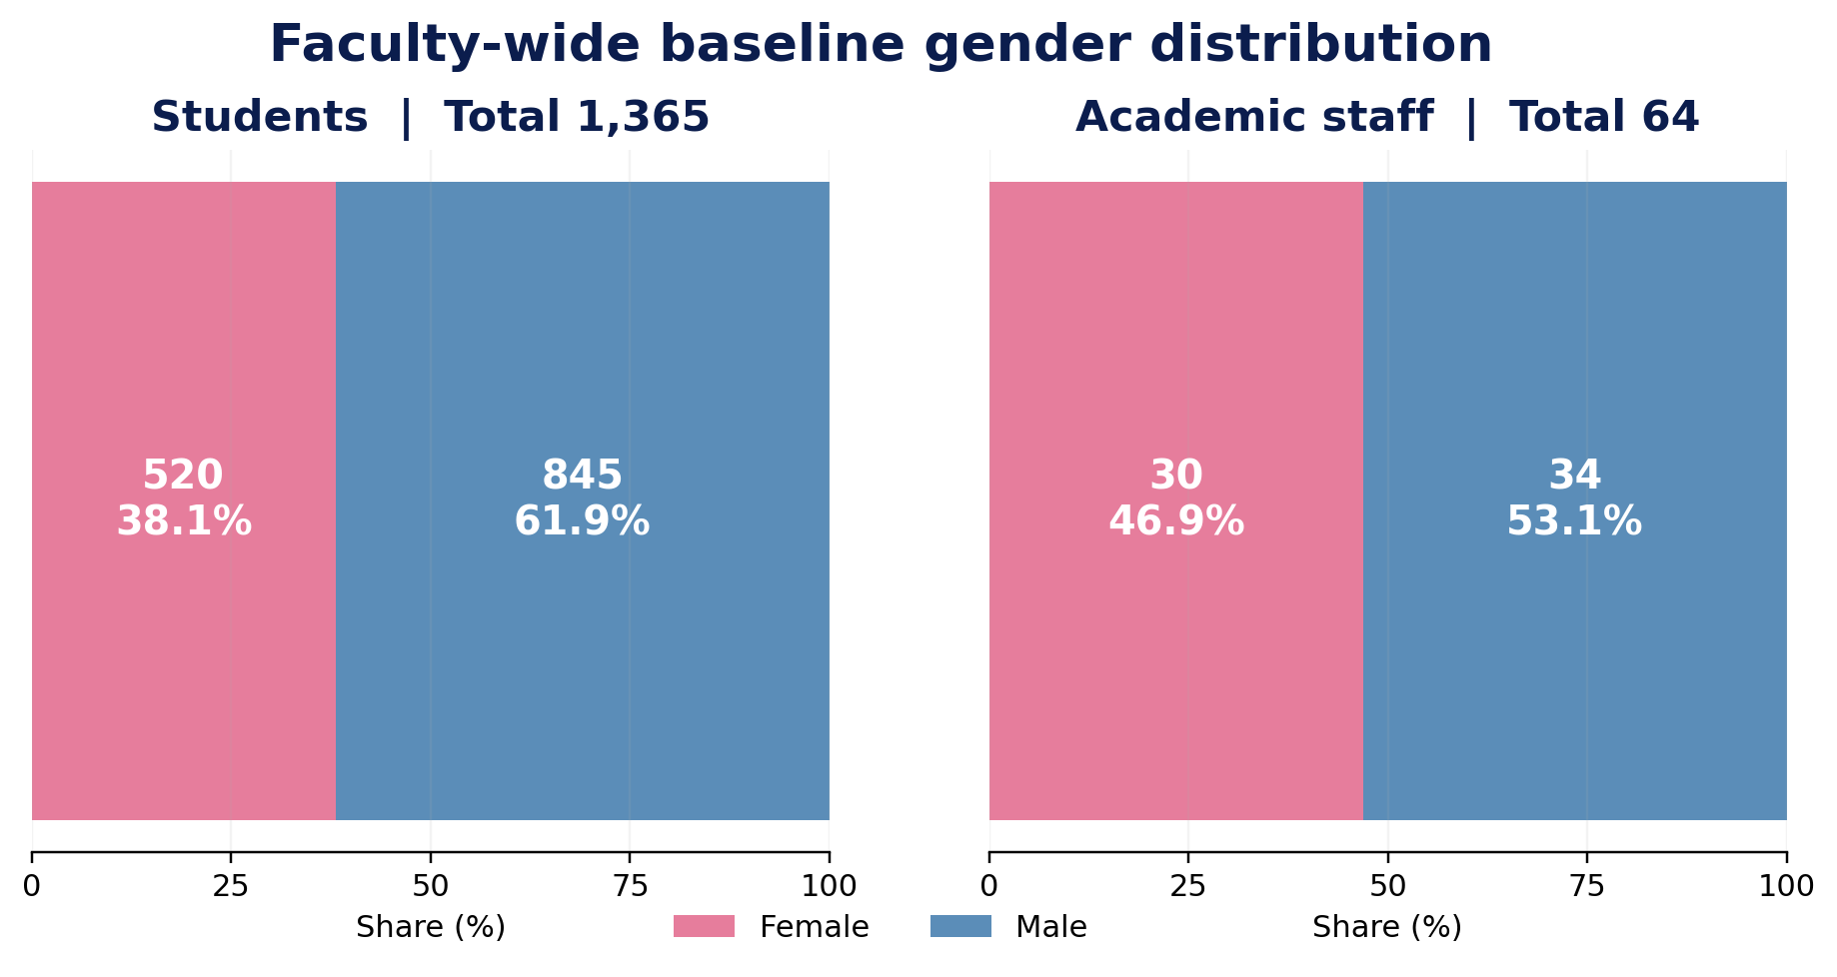
Figure 1. Faculty-wide baseline gender distribution based on the 2026 data supplied for the plan.

The faculty baseline includes 1,365 students, of whom 520 are women (38.1%) and 845 are men (61.9%). The academic-staff baseline includes 64 members, of whom 30 are women (46.9%) and 34 are men (53.1%). In addition, the faculty has 5 administrative staff members, of whom 4 are women (80.0%) and 1 is a man (20.0%). The academic-staff profile is therefore close to overall gender balance, while the student population has a larger male majority. Administrative staff, by contrast, are predominantly women. These differences underline the importance of monitoring staff and student groups separately rather than relying only on an overall Faculty-level figure.

Data to be added / Verified gender-disaggregated data are not yet available for recruitment and shortlisting and equality-related training participation. These areas will be incorporated into the monitoring framework when verified data becomes available.

4.2 Department-Level Baseline
Department / program | F students | M students | F students % | F staff | M staff | F staff %
Public Finance | 56 | 66 | 45.9% | 1 | 6 | 14.3%
International Trade and Logistics | 67 | 124 | 35.1% | 3 | 2 | 60.0%
Tourism Management | 18 | 37 | 32.7% | 3 | 3 | 50.0%
Public Relations and Advertising | 36 | 33 | 52.2% | 3 | 4 | 42.9%
International Relations | 70 | 46 | 60.3% | 3 | 4 | 42.9%
Business Administration (Turkish) | 66 | 170 | 28.0% | 3 | 3 | 50.0%
Business Administration (English) | 74 | 119 | 38.3% | 5 | 2 | 71.4%
Economics (English) | 35 | 52 | 40.2% | 1 | 4 | 20.0%
Economics (Turkish) | 30 | 88 | 25.4% | 2 | 3 | 40.0%
Political Science and Public Administration | 68 | 110 | 38.2% | 6 | 3 | 66.7%
TOTAL | 520 | 845 | 38.1% | 30 | 34 | 46.9%
Note: F: Female, M: Male
Gender representation differs across the ten departments/programs. For this reason, the Faculty will monitor departmental data in addition to the overall Faculty totals. The table below presents the verified student and academic-staff counts used for the 2026 baseline.

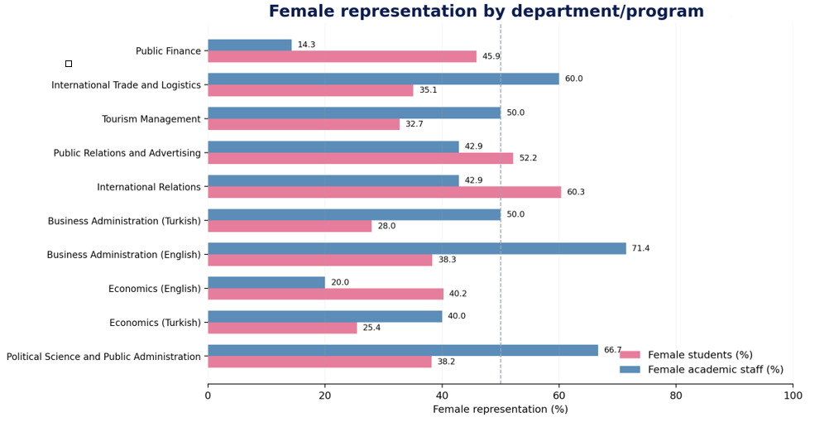
Figure 2. Female representation among students and academic staff by department/program. The dashed line marks 50%; it is a visual reference, not a quota.
The department-level figures show different patterns of representation. Female students form the majority in Public Relations and Advertising and International Relations, while male students form the majority in the other programs included in the baseline. Academic-staff representation is balanced in Tourism Management and Business Administration (Turkish), female-majority in International Trade and Logistics, Business Administration (English), and Political Science and Public Administration, and male-majority in the remaining departments.
Public Finance  122 students: 56 female (45.9%) and 66 male (54.1%). 7 academic staff: 1 female (14.3%) and 6 male (85.7%). | International Trade and Logistics  191 students: 67 female (35.1%) and 124 male (64.9%). 5 academic staff: 3 female (60.0%) and 2 male (40.0%).
Tourism Management  55 students: 18 female (32.7%) and 37 male (67.3%). 6 academic staff: 3 female (50.0%) and 3 male (50.0%). | Public Relations and Advertising  69 students: 36 female (52.2%) and 33 male (47.8%). 7 academic staff: 3 female (42.9%) and 4 male (57.1%).
International Relations  116 students: 70 female (60.3%) and 46 male (39.7%). 7 academic staff: 3 female (42.9%) and 4 male (57.1%). | Business Administration (Turkish)  236 students: 66 female (28.0%) and 170 male (72.0%). 6 academic staff: 3 female (50.0%) and 3 male (50.0%).
Business Administration (English)  193 students: 74 female (38.3%) and 119 male (61.7%). 7 academic staff: 5 female (71.4%) and 2 male (28.6%). | Economics (English)  87 students: 35 female (40.2%) and 52 male (59.8%). 5 academic staff: 1 female (20.0%) and 4 male (80.0%).
Economics (Turkish)  118 students: 30 female (25.4%) and 88 male (74.6%). 5 academic staff: 2 female (40.0%) and 3 male (60.0%). | Political Science and Public Administration  178 students: 68 female (38.2%) and 110 male (61.8%). 9 academic staff: 6 female (66.7%) and 3 male (33.3%).
The comparison between student and academic-staff representation is used only as a monitoring indicator. It helps the Faculty identify where the composition of academic staff differs substantially from the composition of the student body. The Faculty will use these differences to guide further observation and discussion; they are not treated as evidence of unequal treatment on their own.
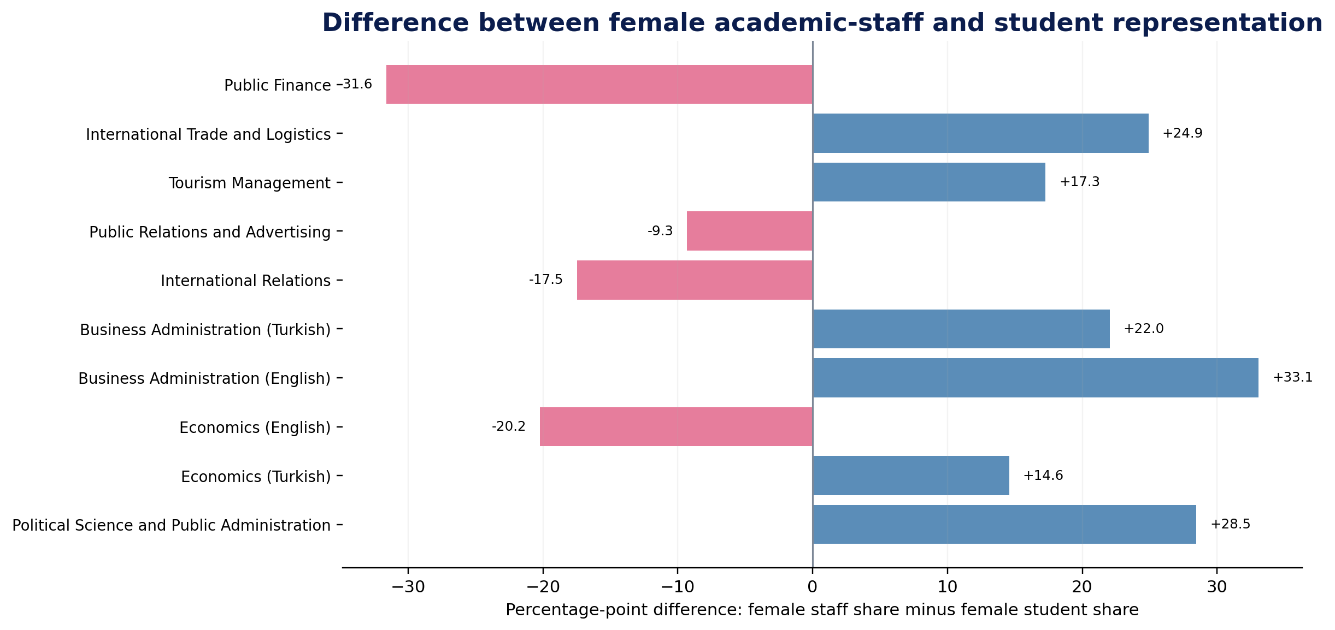
Figure 3. Difference between female academic-staff representation and female student representation within each department/program.

4.3 Leadership and Governance Baseline
The faculty will monitor leadership and decision-making separately from overall academic-staff composition. Although women account for 46.9% of academic staff in the baseline, only one of the eight Heads of Department is female (12.5%). The remaining seven Heads of Department are male (87.5%). This is the clearest representation gap identified in the current leadership data and will be followed throughout the implementation period.
Representation on the Faculty’s main boards is more mixed. Women account for six of the 15 members of the Faculty Board (40.0%) and five of the seven members of the Faculty Administrative Board (71.4%). The faculty will continue to monitor each governance body separately, since aggregate figures may conceal differences between individual decision-making structures.

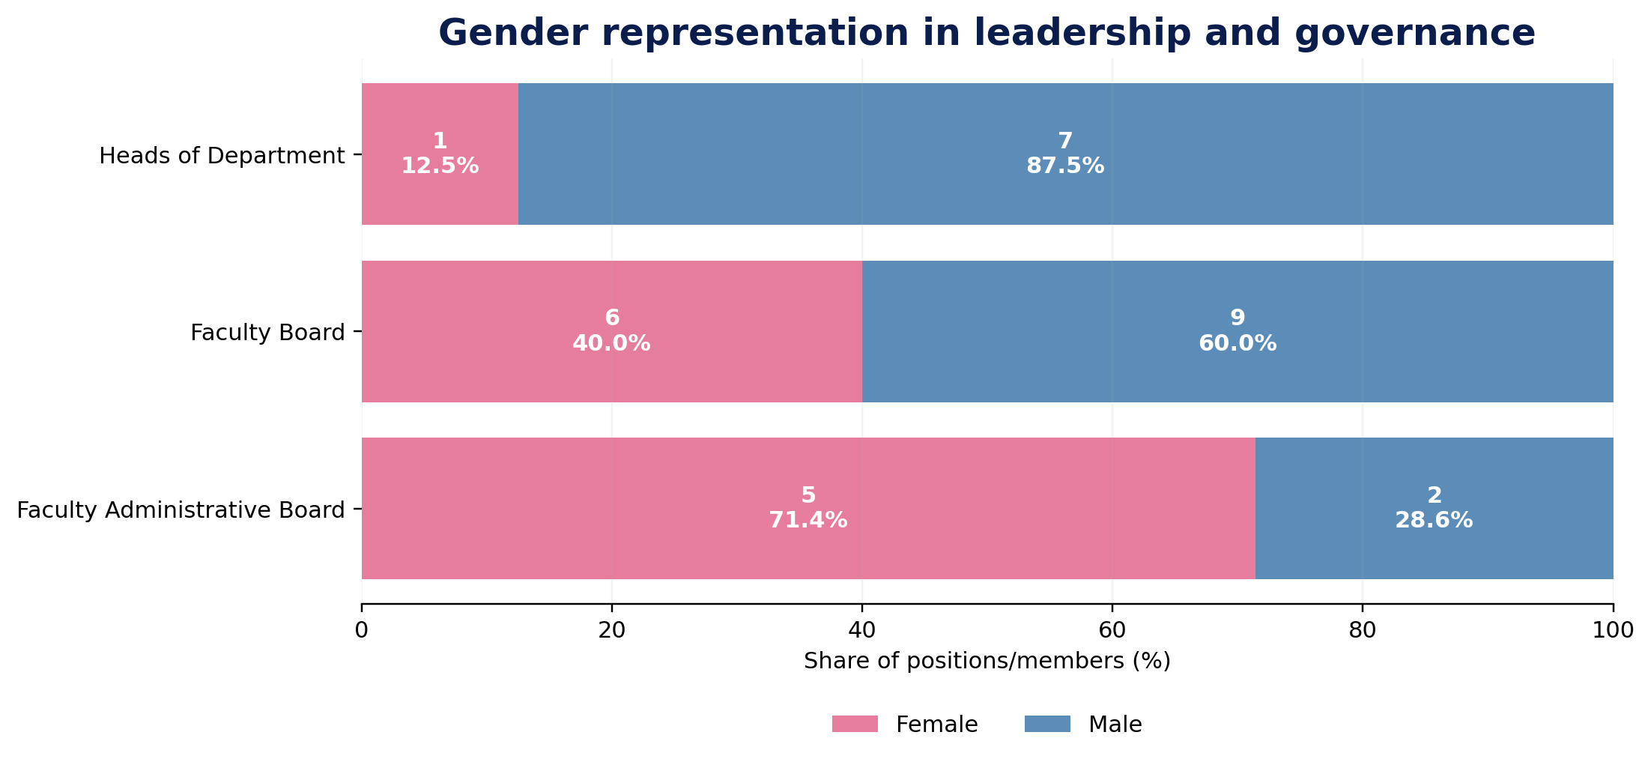
Figure 4. Gender representation in department headship and faculty governance bodies.

The current baseline is limited to the data verified for this Plan. It does not include longitudinal recruitment and promotion data, administrative-staff data, applicant and shortlist data, project leadership, research-support access, training participation or survey results on work–life balance and organizational culture. The faculty will add these indicators when verified data becomes available. Until then, the Plan does not make claims about trends or causes that cannot be supported by the available evidence.

Leadership baseline / Women account for 12.5% of Heads of Department (1 of 8), compared with 46.9% of academic staff overall. The faculty will therefore monitor leadership representation and support leadership-development and mentoring actions during the Plan period.

5. Strategic Priorities and Objectives
In line with Horizon Europe guidance and Atılım University’s existing institutional commitments, the Faculty GEP focuses on five priority areas. Each priority is linked to concrete actions, responsibilities and monitoring indicators for the 2027–2030 period.

Priority 1 — Work–life balance and inclusive organizational culture
The faculty is committed to promoting an organizational culture that supports work–life balance, inclusion and a sense of belonging. The GEP prioritizes regular monitoring of staff experience, care-sensitive scheduling of meetings and events, and the inclusion of gender-equality information in orientation activities. Where relevant University arrangements already exist, the Faculty will focus on communication and effective implementation rather than creating duplicate procedures.

Priority 2 — Gender balance in leadership and decision-making
The faculty is committed to promoting balanced participation in leadership and decision-making. The baseline shows that women are well represented in some governance bodies but are underrepresented among Heads of Department. The GEP therefore prioritizes annual monitoring of leadership and committee composition, balanced candidate pools where feasible, and leadership and mentoring opportunities that support progression.

Priority 3 — Gender equality in recruitment, career progression and academic recognition
The faculty supports gender-neutral, transparent and merit-based recruitment and career progression. The current baseline does not include verified recruitment, shortlisting or promotion data. The GEP therefore prioritizes inclusive language and transparent criteria, bias-awareness training for selection and evaluation bodies, and future monitoring of access to research funding, conference support and professional-development opportunities.

Priority 4 — Gender dimension in teaching and research
The faculty will support the integration of the gender dimension into teaching and research where it is relevant to the subject matter, research question, data, method or expected impact. The GEP prioritizes course and program screening, guidance on diverse cases and reading materials, and training for researchers on the gender dimension in Horizon Europe proposals. The aim is to strengthen academic quality and relevance without requiring gender content where it is not substantively applicable.

Priority 5 — Safe environment: prevention of gender-based violence and sexual harassment
The faculty is committed to maintaining a safe, inclusive and respectful environment for staff and students. Atılım University already has a Senate-approved policy addressing gender-based discrimination, sexual harassment, sexual assault, digital harassment and retaliation. The Faculty GEP therefore prioritizes awareness of existing procedures and supports mechanisms, regular training, coordination with relevant University units and confidential monitoring of trust and awareness.

6. Action Plan 2027–2030
The following action plan sets out the measures to be implemented during 2027–2030. Each action includes an indicator, starting point where available, intended target or output, responsible unit and implementation period. Actions for which verified baseline data are not yet available are identified as areas to be established during implementation rather than being assigned estimated values.

Code | Action | Indicator | Baseline | Target/output | Responsible | Period
1.1 | Conduct an annual work–life balance and belonging survey. | Response rate; annual findings report | 2027 baseline | Annual report | GEP Committee | 2027–30
1.2 | Adopt a care-sensitive principle for scheduling Faculty meetings and events. | Approved principle; share of sampled meetings within agreed hours | To be established | ≥90% | Dean’s Office | 2027
1.3 | Include a gender-equality module in new staff and student orientation. | Completion/participation rate | To be established | ≥80% | Dean’s Office / Departments | 2027–30
2.1 | Monitor the gender composition of leadership, boards and committees each year. | Annual representation table | Heads: 1F/7M; Board: 6F/9M; Admin Board: 5F/2M | Annual publication | Dean’s Office | 2027–30
2.2 | Strive, where feasible, for balanced candidate pools for speakers, juries and representation assignments. | Share of relevant processes documenting a balanced candidate pool | To be established | Year-on-year improvement | Departments | 2027–30
2.3 | Establish a leadership and mentoring programme to support leadership development. | Participants; satisfaction; progression follow-up | 0 | ≥10 participants/year from 2028 | Dean’s Office | 2028–30
3.1 | Review recruitment and evaluation texts for inclusive language and transparent criteria. | Share of relevant processes reviewed | To be established | 100% | HR / Departments | 2027
3.2 | Provide short bias-awareness training for selection and evaluation committee members. | Share of relevant members completing training | To be established | ≥90% | HR / GEP Committee | 2027–30

6.1 Implementation logic for Priorities 1–3
Priorities 1–3 focus on organizational culture, leadership and institutional processes. The faculty will establish regular monitoring of work–life balance and belonging, apply care-sensitive scheduling principles, strengthen orientation, monitor leadership representation, support mentoring and review recruitment and evaluation practices. Where University-level systems are responsible for a process, the faculty will work through those systems rather than create parallel procedures.

6. Action Plan 2027–2030 — continued
Code | Action | Indicator | Baseline | Target/output | Responsible | Period
3.3 | Monitor access to research funding, conference support and professional development by gender. | Annual opportunity-access report | To be established | Annual report | Dean’s Office / ARGEDA-TTO | 2027–30
4.1 | Screen relevant course information packages for the gender dimension. | Share of relevant courses/programmes screened | To be established | 100% screened by 2028 | Departments / Education Committee | 2027–28
4.2 | Provide annual training for researchers on the gender dimension in Horizon Europe proposals. | Training events; participants; documented integration examples | To be established | ≥1 training/year | ARGEDA-TTO / Faculty | 2027–30
4.3 | Prepare guidance on diversity in cases, reading lists and invited speakers. | Guide issued; annual implementation examples | 0 | Guide + annual example | Education Committee | 2028
5.1 | Make existing institutional reporting, referral and support channels clearly visible on a Faculty-accessible page. | Page published; usage/access evidence where available | To be established | Published and maintained | Dean’s Office / relevant units | 2027
5.2 | Provide annual awareness and training on harassment, gender-based violence, retaliation and safe intervention. | Training delivered; participation | To be established | ≥1 training/year | Relevant University units / Faculty | 2027–30
5.3 | Monitor awareness of procedures and perceptions of trust while protecting confidentiality. | Anonymous survey indicator; improvement decisions | 2027 baseline | Annual review and action where needed | GEP Committee | 2027–30
6.2 Implementation roadmap
2027 — Establish and operationalize | Confirm governance; complete missing baseline categories where accessible; launch survey; adopting meeting-time principle; begin orientation, recruitment-text review, bias-awareness training, governance monitoring and visibility of reporting/referral channels.
2028 — Deepen integration | Conduct the formal mid-term review; complete the planned course/program screening; issue the diversity guide; begin the leadership and mentoring program; revise targets if the evidence shows that actions are too weak, too ambitious or no longer relevant.
2029 — Consolidate practice | Continue annual monitoring and training; use accumulated data to assess trends rather than single-year fluctuations; embed effective actions in routine Faculty processes and address persistent gaps through targeted follow-up.
2030 — Evaluate and renew | Assess implementation, evidence quality and change against the 2026/2027 baseline; document lessons learned; prepare recommendations and the next planning cycle.

Implementation will take place in stages. In 2027, the faculty will confirm governance arrangements, complete available baseline categories and begin the core monitoring and training actions. In 2028, the Plan will place greater emphasis on curriculum screening, the diversity guide, leadership and mentoring, and the mid-term review. In 2029, successful practices will be consolidated. In 2030, the faculty will complete the final evaluation and prepare recommendations for the next planning period.

7. Monitoring, Evaluation and Annual Indicators
The faculty will monitor implementation through regular evidence collection and review. The Faculty GEP Committee will maintain a six-monthly record of activities, indicators, evidence and outstanding issues. The Dean’s Office will review progress annually. A mid-term review will be conducted at the end of 2028 and a final evaluation at the end of 2030. The results will be used to revise actions and targets where necessary and to inform the next planning cycle.

Indicator area | Evidence to be monitored | Frequency
Students | Female/male counts and shares by department/programme | Annual
Academic staff | Female/male counts and shares by department/programme | Annual
Administrative staff | Sex-disaggregated count when verified data are available | Annual
Leadership/governance | Heads of Department and major boards/committees | Annual
Recruitment/progression | Applicant, shortlist, appointment and progression indicators where data are available | Each cycle / annual
Opportunity access | Research funding, conference and development support by gender | Annual
Training | Number of activities, participants and completion/feedback | Annual
Teaching/research integration | Screening and documented integration examples | Annual
Work–life / belonging | Survey indicators | Annual
Safety / awareness | Awareness of reporting/referral routes and trust indicators | Annual

7.1 Communication, Participation and Review
The faculty will communicate the GEP to academic staff, administrative staff and students after institutional approval. Relevant stakeholders will be invited to provide feedback on implementation. The faculty will maintain accessible information on the Plan, progress and relevant University procedures, while protecting confidentiality and personal data. The Plan will be reviewed annually and updated where institutional needs, evidence or applicable requirements change.
8. Approval and Entry into Force
This Plan will enter into force following completion of the required institutional approval process. Before publication, the faculty will verify the baseline figures, confirm the responsibilities of the units named in the action plan, identify the resources and training schedule for implementation, and check consistency with relevant Atılım University policies and any University-level GEP or equivalent strategy. Following approval, the signed Plan will be made publicly available and communicated to the faculty community.
8.1 Approval checklist
- Baseline student, academic-staff, leadership and governance figures verified.
- Administrative-staff baseline and any other required personnel data assigned to a responsible data owner for completion.
- Responsible units/persons formally confirmed, and implementation roles accepted.
- Annual resource commitment and training schedule confirmed.
- Consistency with Atılım University policies and any University-level GEP/equivalent strategy checked.
- Faculty Board / relevant governance approval completed where required.
- Senior-management adoption/signature completed, and the final document published on the public website.
References
Atılım University (2020). Policy Document on the Prevention of Gender-Based Discrimination, Sexual Harassment and Sexual Assault. Senate Decision No. 12, 24 July 2020.
Atılım University. Regulation of the Women’s Studies Research and Application Centre (KASAUM).
European Commission. Gender equality in research and innovation: Horizon Europe Gender Equality Plan eligibility criterion and thematic areas. Current public guidance was accessed in September 2026.
European Commission. Horizon Europe Guidance on Gender Equality Plans.
European Institute for Gender Equality (EIGE). Gender Equality in Academia and Research (GEAR) tool: step-by-step guidance for setting up, implementing and monitoring a GEP.
Faculty baseline dataset supplied for this plan (2026): department/programme student and academic staff counts; Heads of Department; Faculty Board; Faculty Administrative Board.

Document status at issue / Draft for institutional review. Only verified numerical data supplied for preparation of the Plan are reported. Missing data remain implementation and data-completion items.

